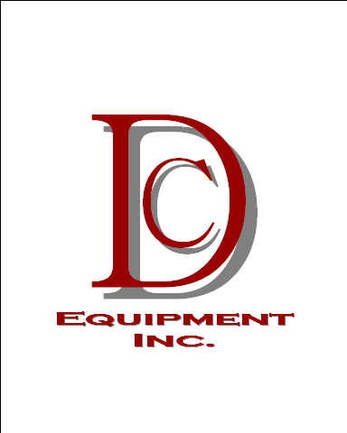
P.O. Box 184 ● Old Mill Road
Geraldine, Alabama 35974

Phone 256-659-4707 ● Fax 256-659-5242
E-mail: sales@dcequipmentinc.com

January 7, 2021

Wayne Farms
Union Springs, AL

To: Jason Whitehead
Subject: DC- Job# W1559 Add Back Hopper Incline

Quote# PQ190

Motor and Gearbox-
1) 0010-0040 2HP Inverter Duty Motor $930.00
1) 0011-0412 50:1, 56C, 1-1/2” Bore, Smooth HB Gearbox W/ Torque Arm $2,450.00
1) 0011-9000 Sterling Back Stop for KSS04 Gearbox Left Hand $515.00

Belting and Sprockets-
10FT) 0014-204665 800S 24” Wide 6” Flights 12” Centers w/ Center Notch $1,970.00
1) 0013-0018 800S 6.5” Diameter, 10 Tooth, 2” Square Bore Sprocket $37.50

Bearings-
1) 0012-2023 (Dodge# 136829) F4B-SCEZ-104-SHSS 1-1/4” 4-Bolt Bearing $105.00
1) 0012-0202 (Dodge# 136831) F4B-SCEZ-108-SHSS 1-1/2” Dodge SS 4-Bolt $140.00

TOTAL $6,147.50

Lead Times- 4 Days on everything except Belting (Intralox-10 Days)
Plus Tax & Shipping
Changes in Specs may result in Price Change
Void 30 Days from 8/19/2020
Very Respectfully,

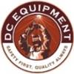 | Jeremy Hendrix  Part Sales / Purchasing  DC Equipment Inc.  Office: 256-659-4707  Cell: 256-706-0282  Jeremyh@dcequipmentinc.com

